Senses Practical

Materials
For this experiment you need:
- Calipers [Measuring tool purchased at auto part or hardware store] AutoZone Caliper
- Paper
- Writing Utensil
- Eye Shades
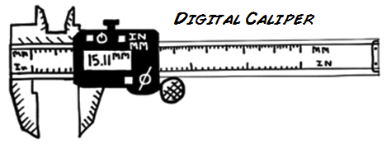
Procedure
Working with a friend you are going to test each other's two-point threshold. A two-point threshold test seeks to find at what distance apart does a person perceive one point as two separate points. To test this, two points start together touching the skin. Incrementally they are pulled further apart and reapplied to the skin until the subject can clearly tell there are two different points.
You will take measurements from four different body part locations: Fingertip, Cheek, Forearm, and Calf. You will perform this experiment twice (ascending and descending with the caliper). Finally, the test subject must always keep their eyes closed (use the eye shades to be sure)!
Experiment Steps:
- Before you start this experiment, be sure that you know how to use the caliper and how to open and close it. Practice touching your arm with it at different millimeter (mm) readings. It is important during the experiment that you touch your partner's skin with both tips at the same time; otherwise, they will easily be able to tell there are two points. Once you have the hang of it you are ready to begin!
- Have your partner place the eye shades on and sit in a chair with a table in front of them. Then your partner places their arm on the table with their palm facing up. Now you takes the calipers, make sure they read 0 mm, and start with your partner's finger tip.
- Touch the calipers to their finger tip and ask them if they feel one point or two points. They should say one point, as the measurement is 0mm. Remove the calipers and increase the space by 2 mm. Reapply the calipers, be sure to touch both tips at the same time, and ask again. If they still only feel one point, increase by another 2 mm and reapply.
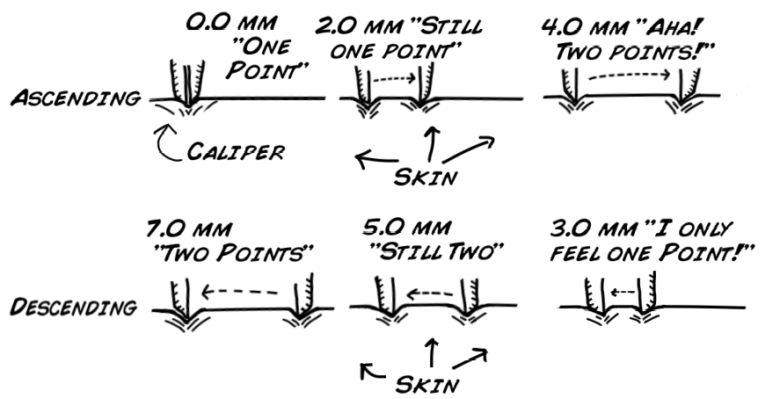
- Continue this cycle until your partner feels two points. Record the millimeter measurement in the chart below.
- Do this test again for the top of one forearm, one facial cheek, and the back of one calf. For the calf have the subject sit and rest their foot on a chair.
- Switch positions of experimenter and subject; run the test again.
- After you have both tested each other run the whole experiment again (Steps 1 to 5); however, this time instead of starting the caliper at 0mm and ascending, you will start at a large distance apart and descend from 2 points until your partner can only feel one point.
- For example, if your partner could tell that one point became two points at 6 mm on their finger tip, start the descending experiment at 10 mm. This ensures that your partner will feel two different points.
Here is a table for you to record your numbers and averages:
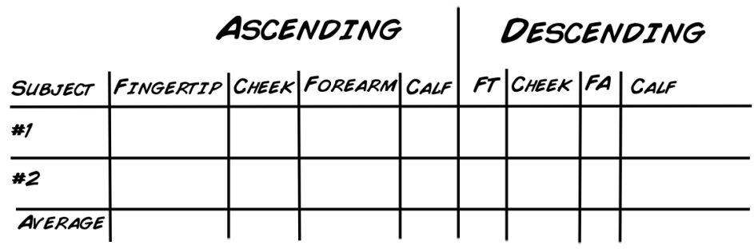
Questions to Answer and Consider
- Why can your fingertip detect such small distances between points while your arms and legs cannot?
- Would you expect to see a difference in males vs. females for the four recorded areas? What about children vs adults?
- Why doesn't your brain have the sensitivity of your fingertips all over your body?

